**Follow below steps to get ease with this software :**

1. Import image with **open** icon.

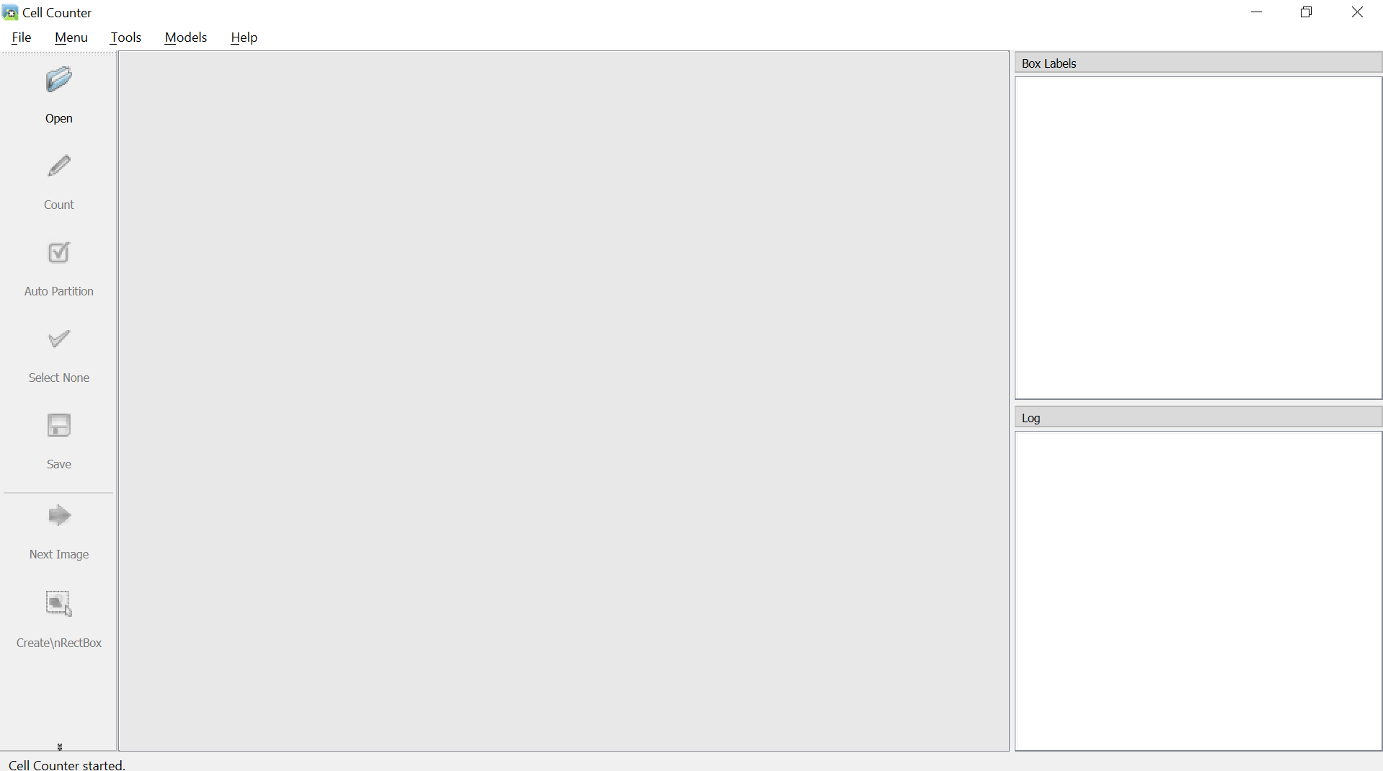



1. Imported image in central panel.

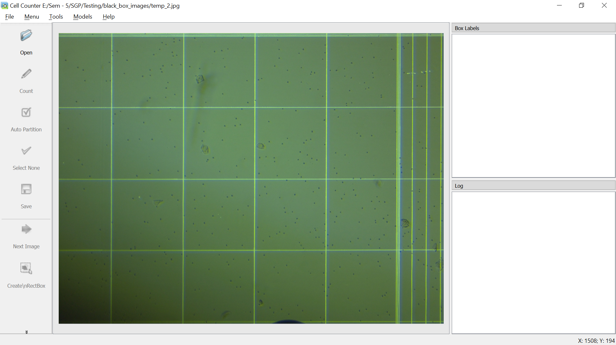

1. Select options from below list

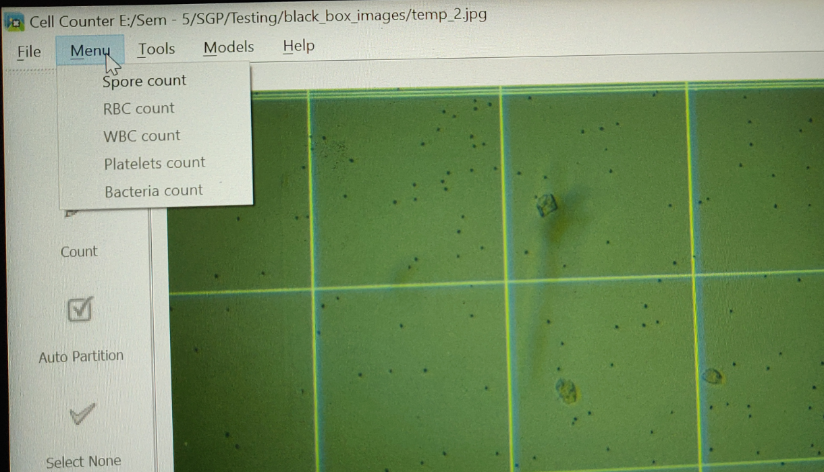

1. By selecting option **count** button, **Fixed Partition** button, **Select None** button enable and on Log one can find that image is divided into 16 equal parts automatically.

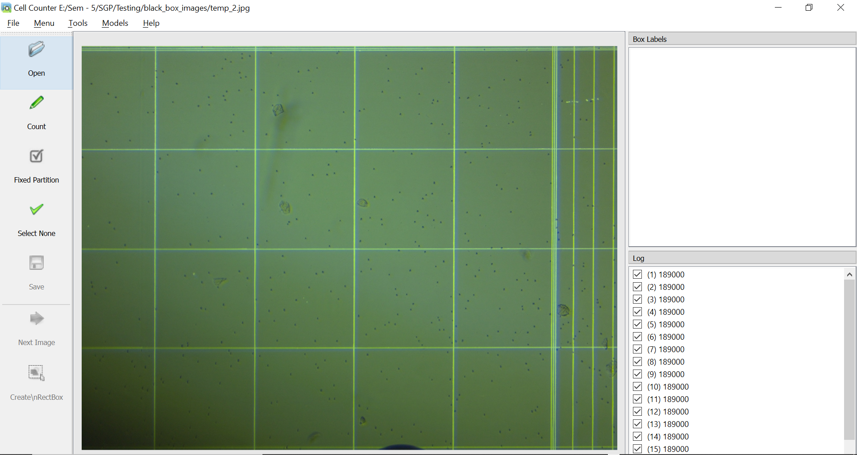

1. By clicking on 10th box, a blue bordered box display on image for indication of that selected box is this particular area from image and only those regions passed for **count** purpose (Note that , by default image automatically partitioned into 16 equal parts).

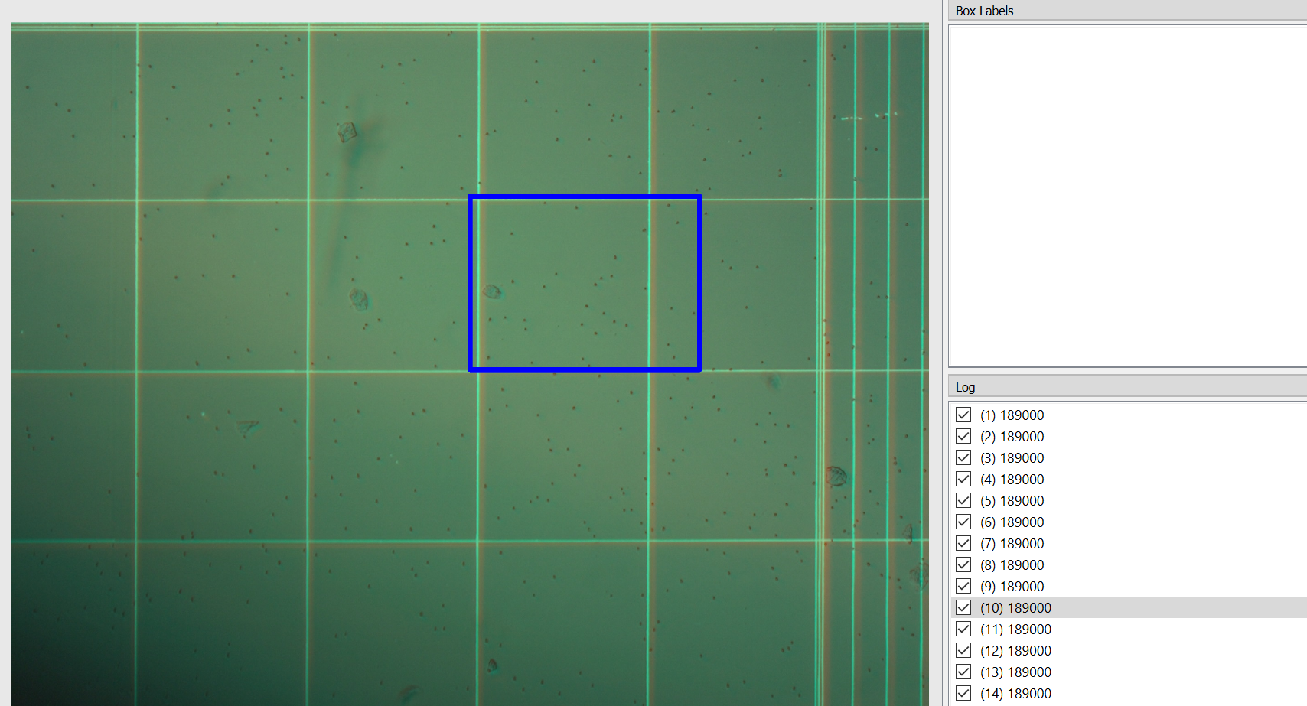

1. If you want to use Fix partitioning mode, then from image, system tries to detect lines and by finding average of all lines height and width, boxes are divided into different boxes. By clicking on 28th box small part indicated with blue border selected for count purpose.

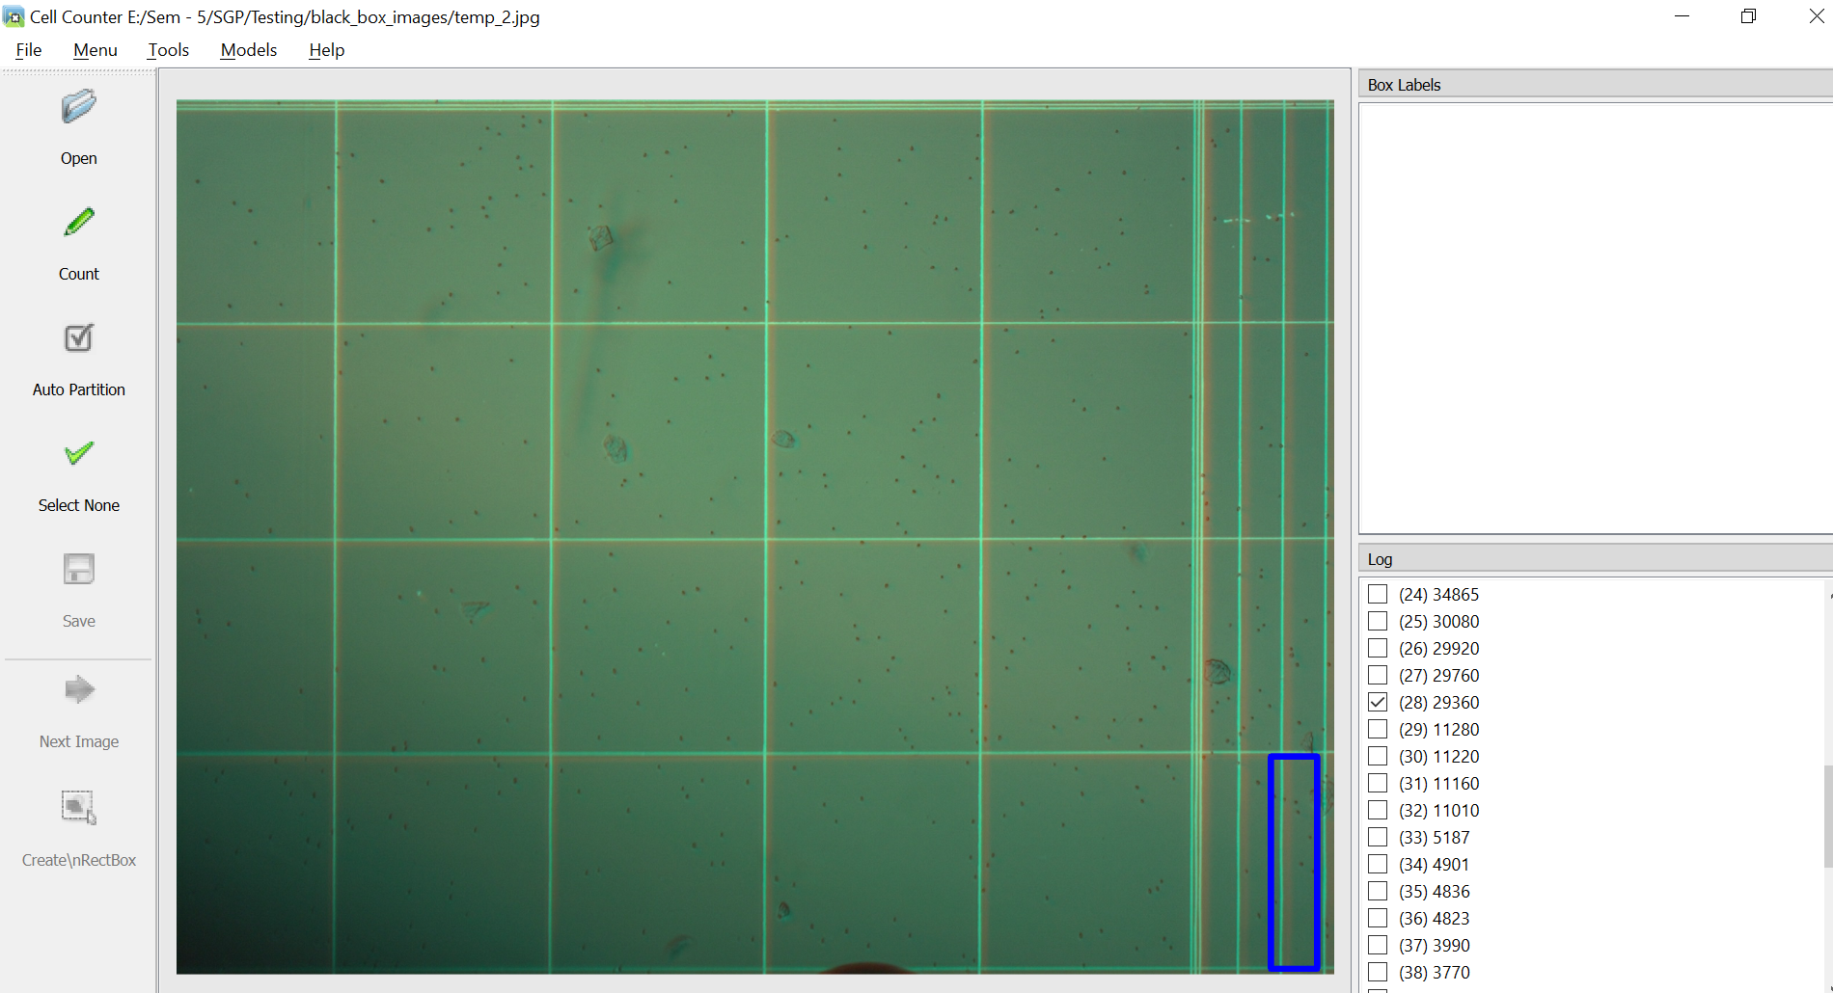

1. You can select all boxes, one box or as per your requirements and then click **count** button, it took some load time and then it will display **total count** on right side panel and also individual count for each box is also displayed next after name of that box, which is shown in below image:

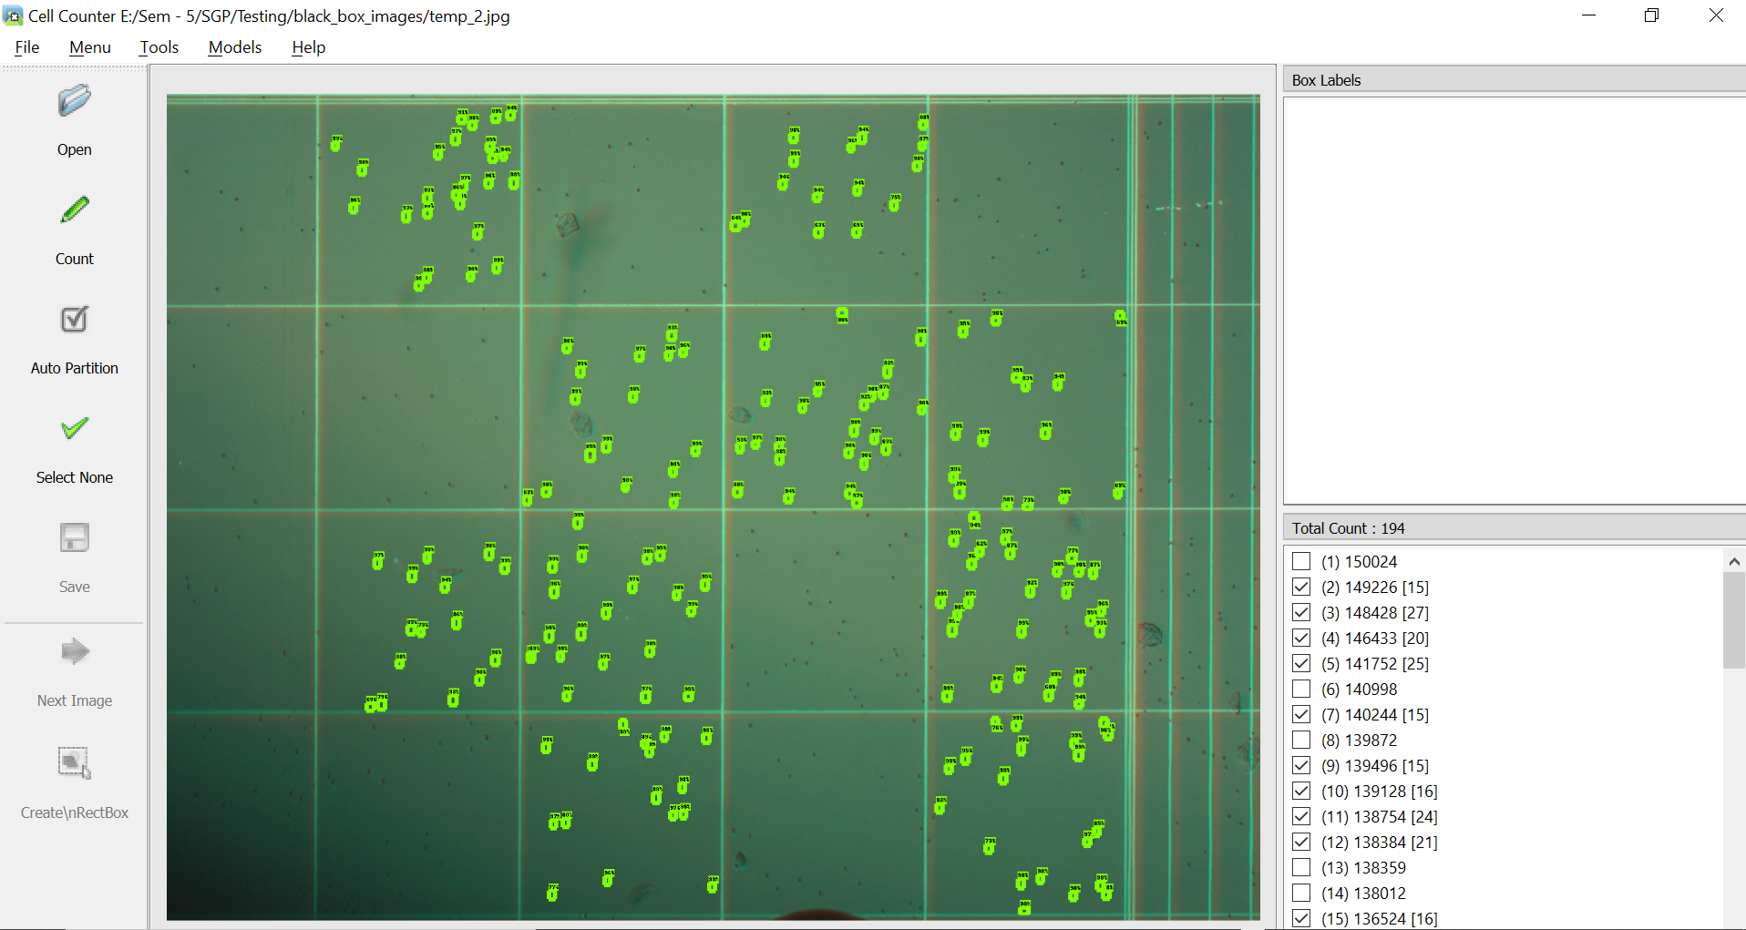



1. One can zoomed in to check that particular each spore cell is matched with how many percent to get more accurate spores.

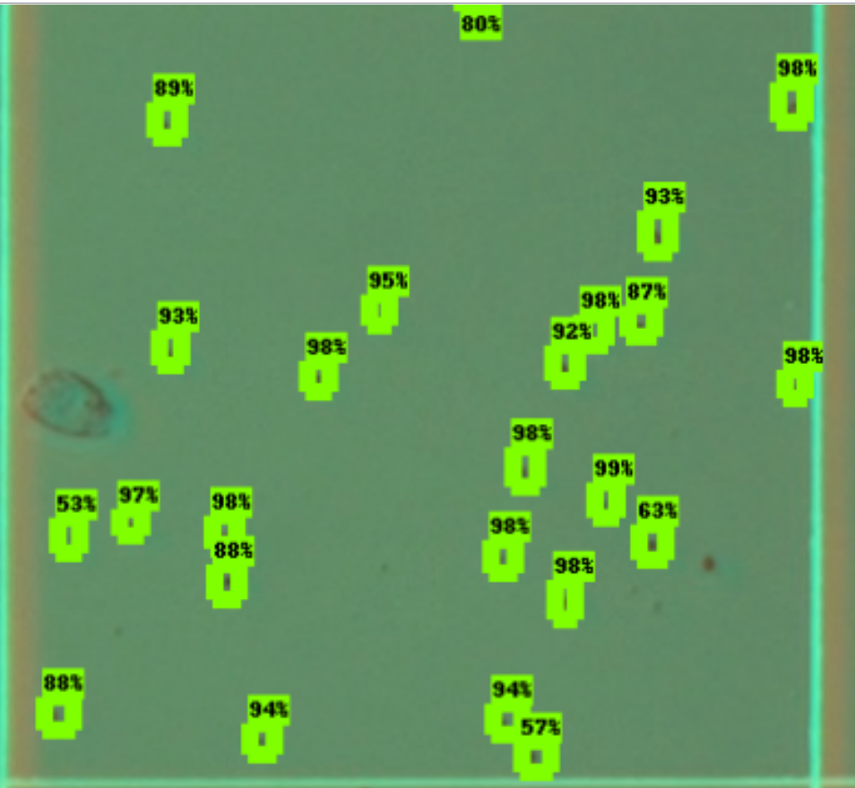

1. All above steps for any kind of options select from **Menu** option.

But if we all know that in this field there are millions of diversity so fix modules cannot be useful for everyone who belongs to this field so for those **DarkCoders** provide another functionality discussed as below:

1. By clicking on **Tools -> Label Image** will provide all boxes detected and separated by system on **Log panel.**

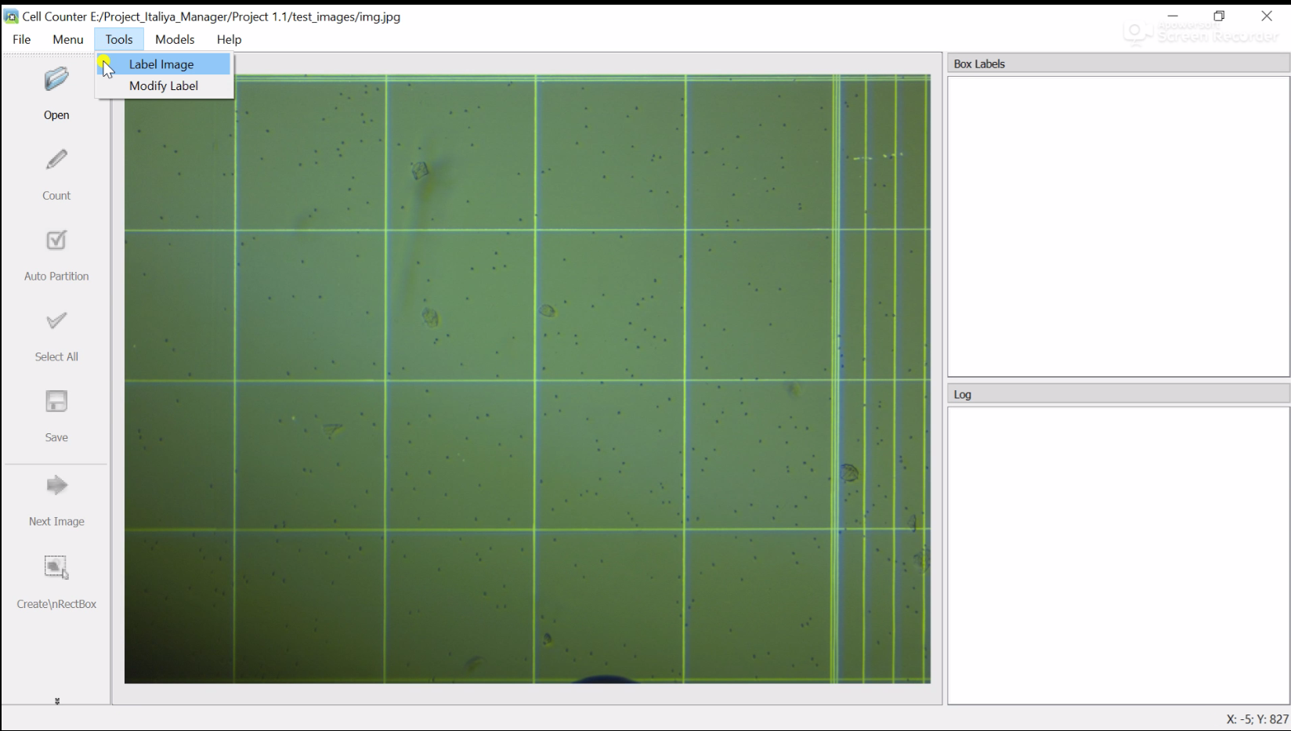

1. Log panel filled with all boxes those are detected, after it select only those boxes from which you want to choose reference that this thing particular called as this and label as much as one can provide for better accuracy.

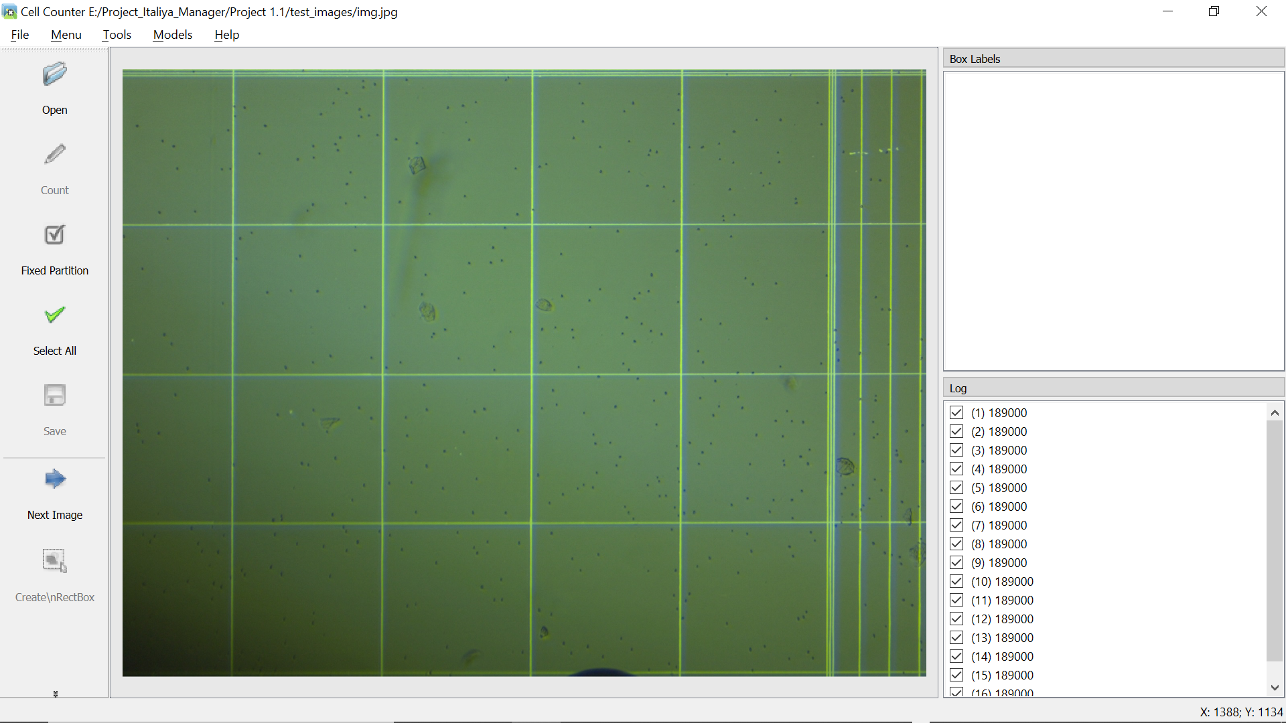

1. For simplicity, We took 2 boxes from given list, then click on **Next Image** button.

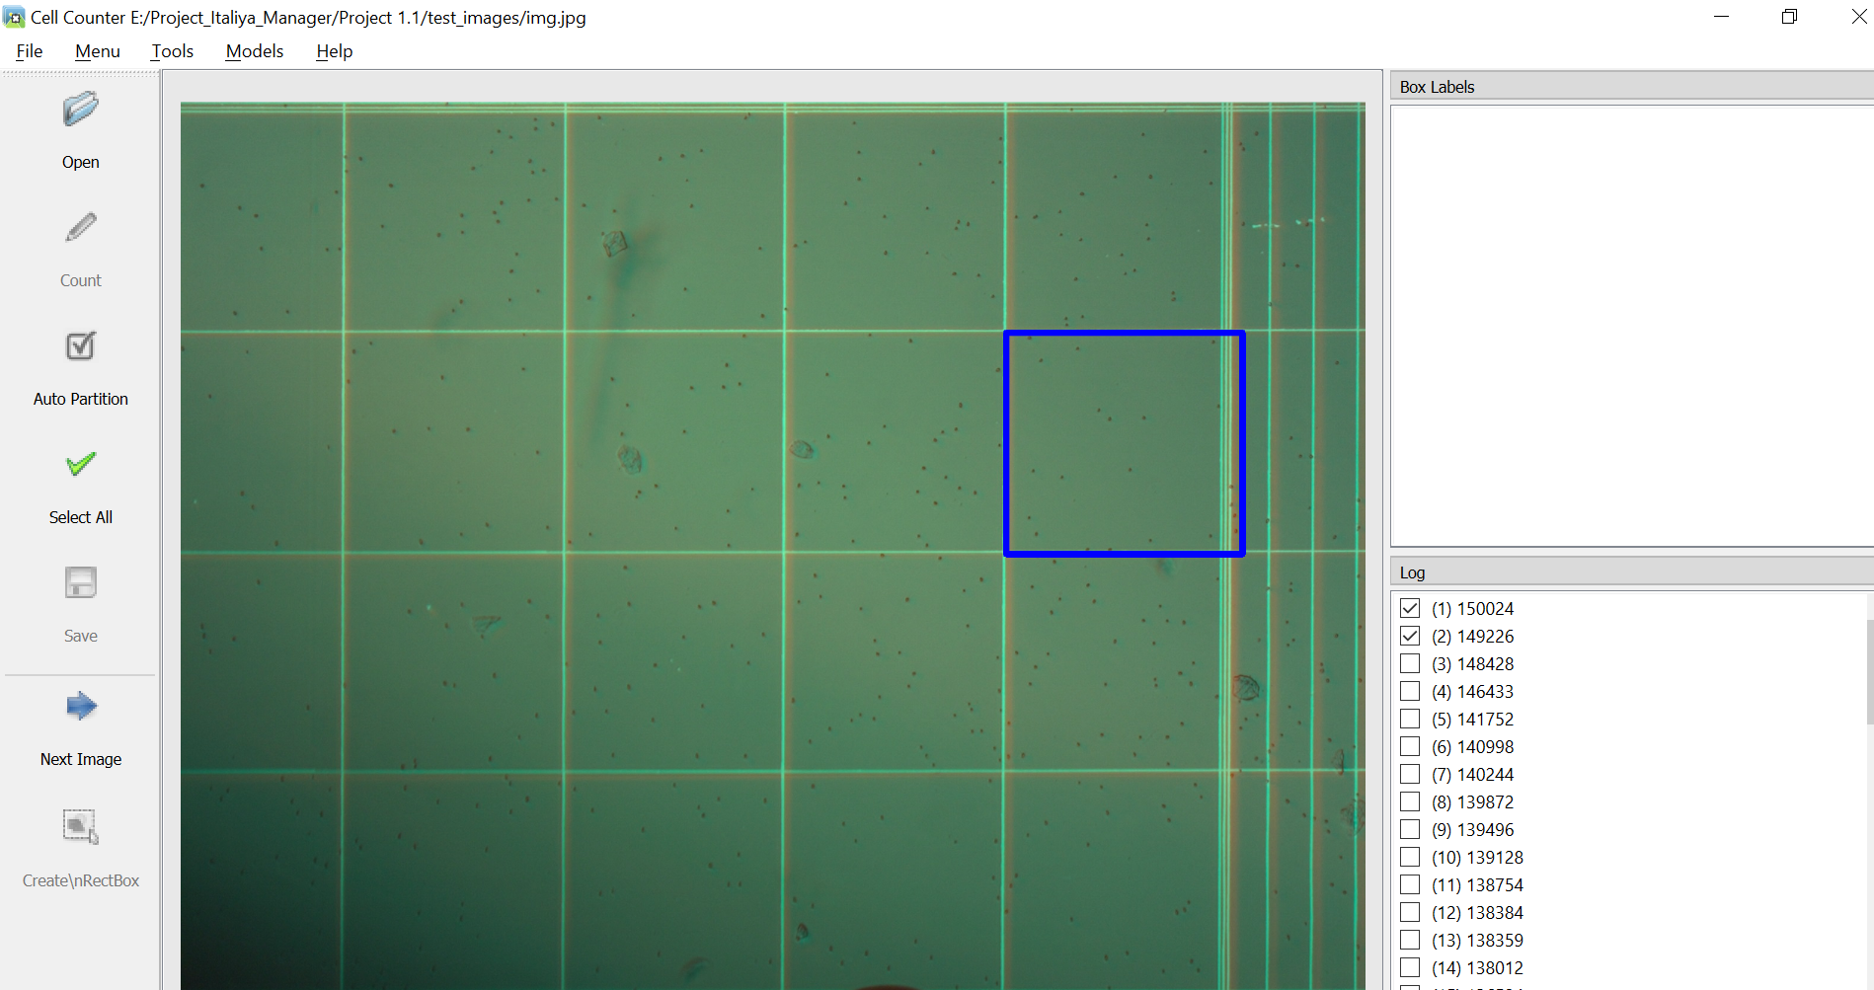

1. User will get one box form selected 2 and then click on **create RectBox** and choose reference and apply appropriate label.

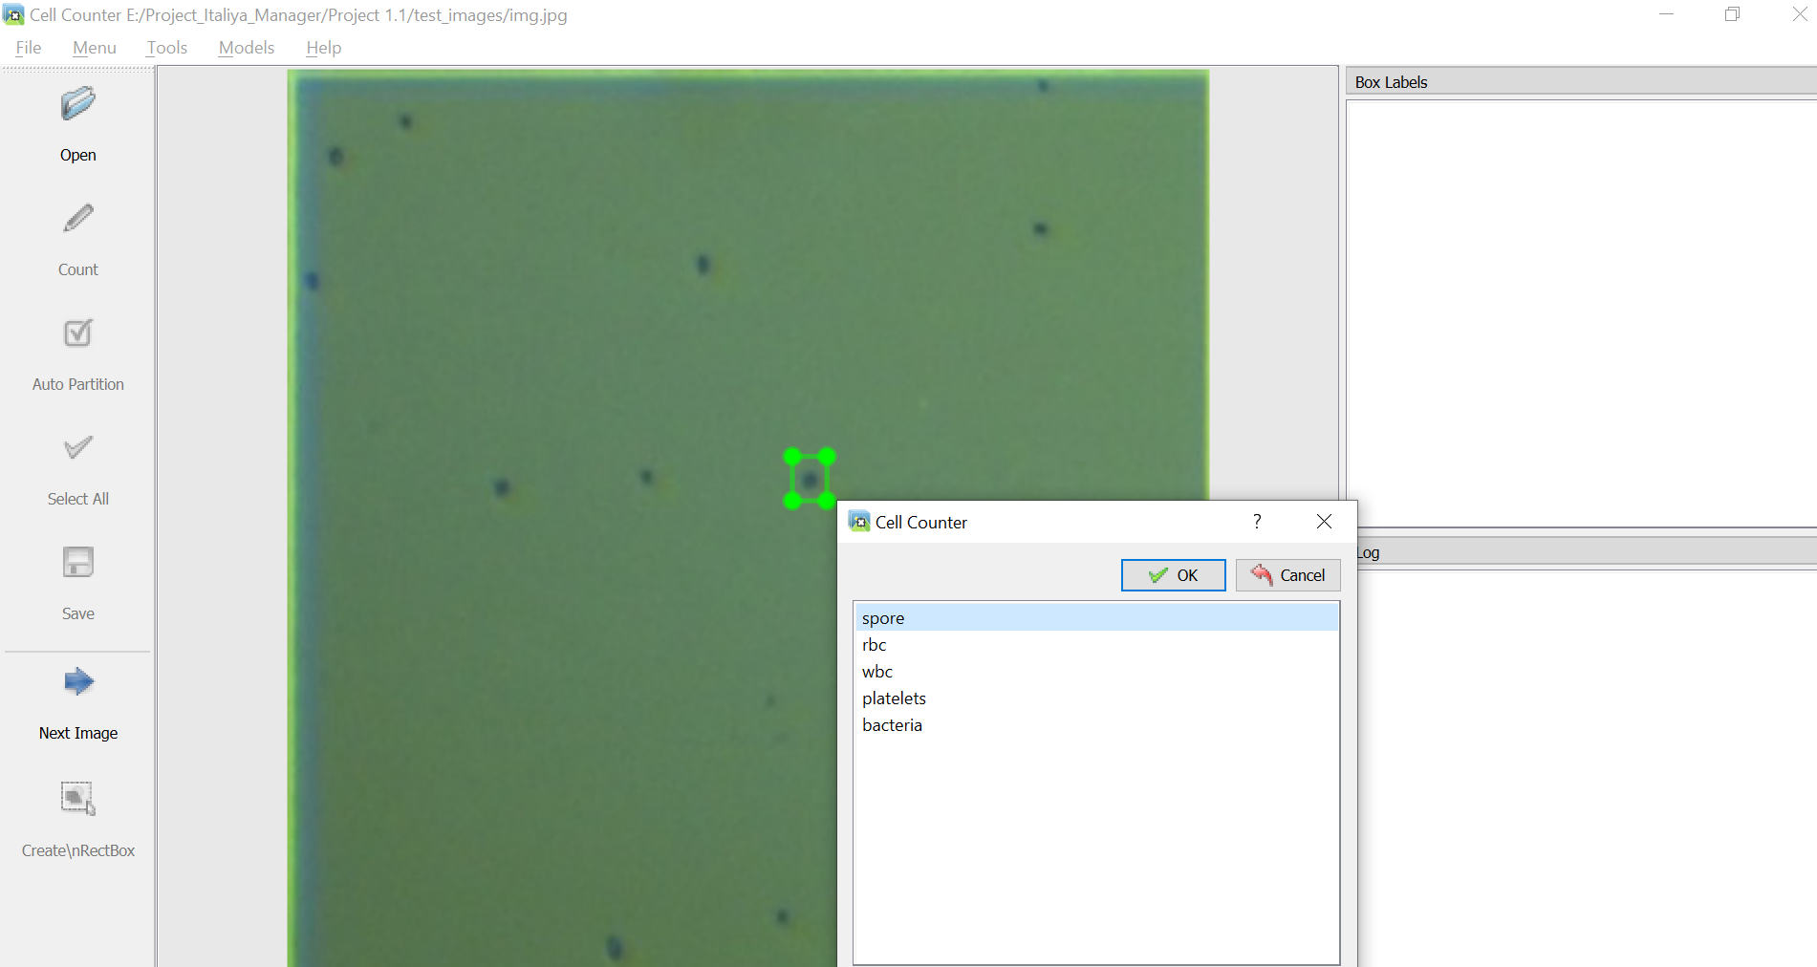

1. User can create multiple references boxes by clicking on **Duplicate RectBox** button and on right side panel named **Box Labels** will display all boxes created on image.

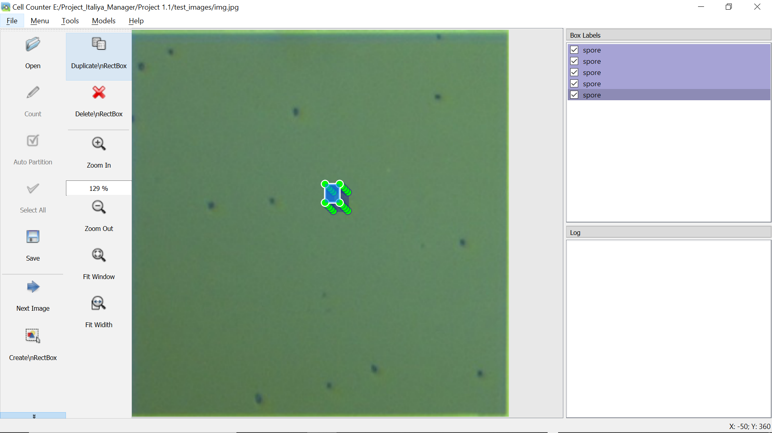

1. User can select as many as he/she wants and after selecting references image will look like :

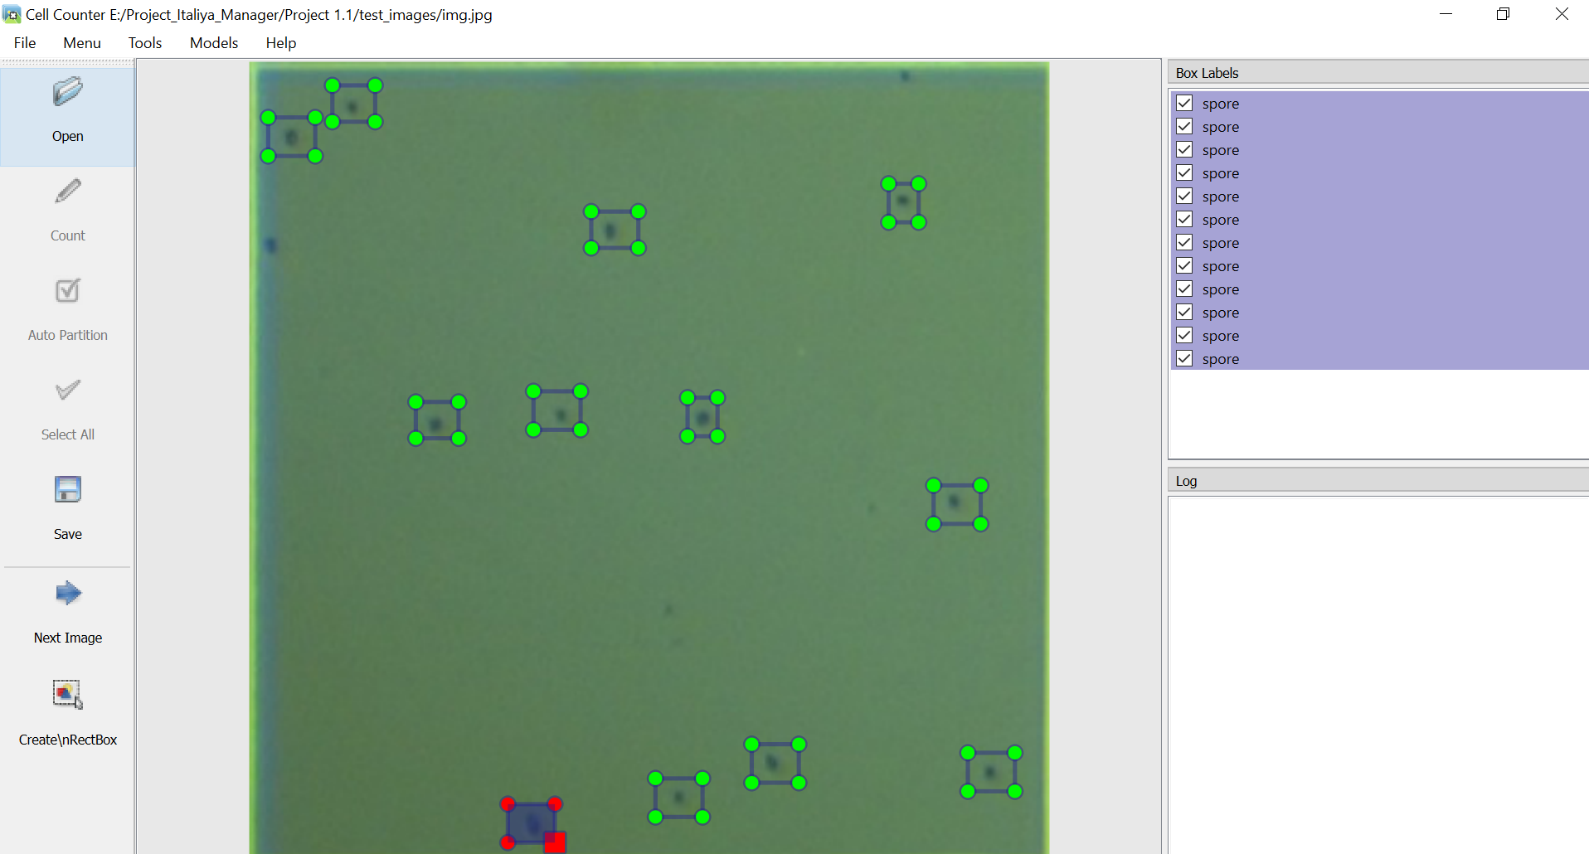

1. **NOTE :-** Please select **Save** button after choosing references from one box and then repeat this procedure for all boxes.
2. This steps are for labeling and referencing only, now again open main image and go on

**Models -> Create Model** :

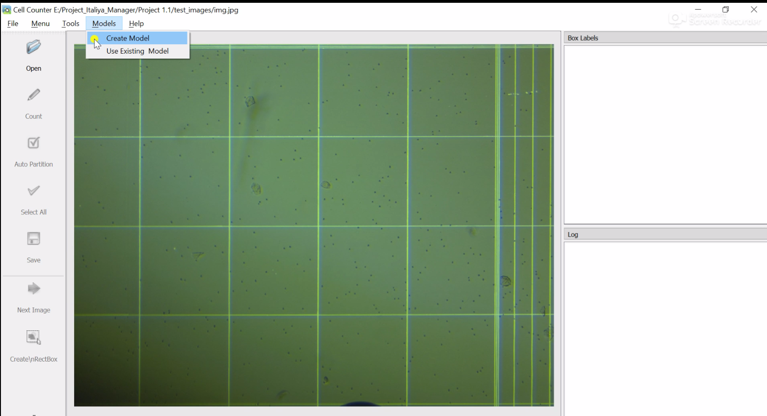

1. After clicking , new window will open for giving model name and copy that below command before pressing **Next** button

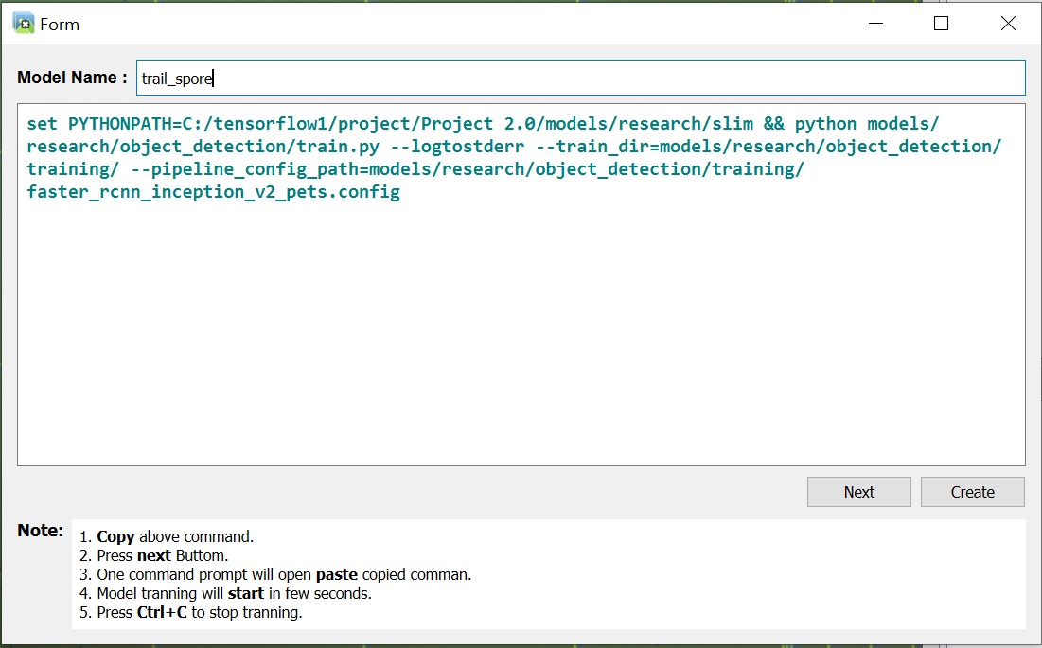

1. After copying command, enter **Next** button, and cmd terminal window get open and copy paste that code show to user just ahead and press enter.

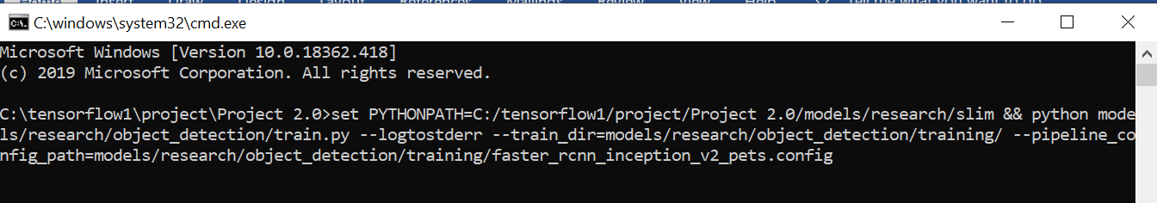

1. After running for several minutes , user can stop it if he/she has time constraint or continue process for long time for better accuracy.

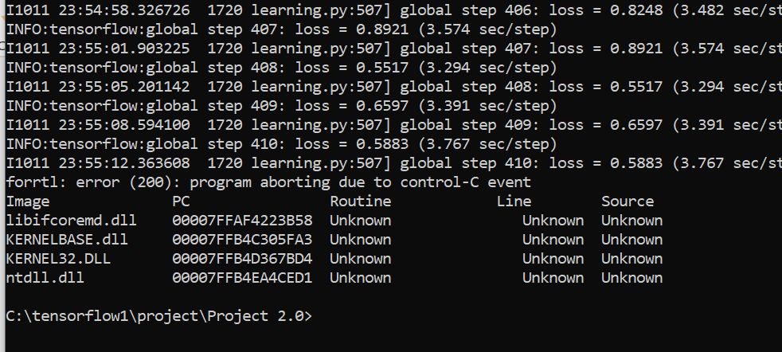

1. After stopping training, user move back to System where he/she has to press **create** button, it will return to homepage.

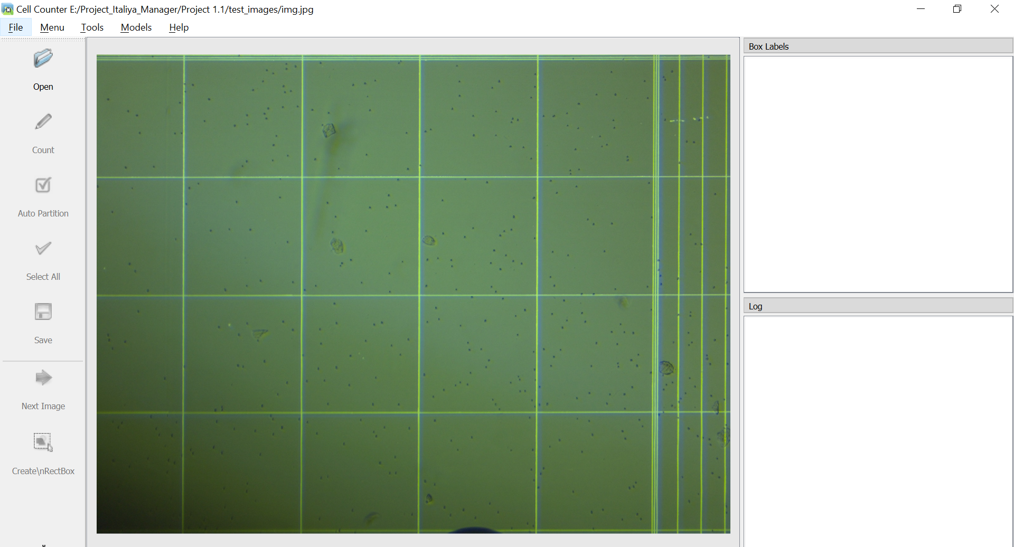

1. Go to **Models-> Use Existing Model** and then select model which is trained just now.

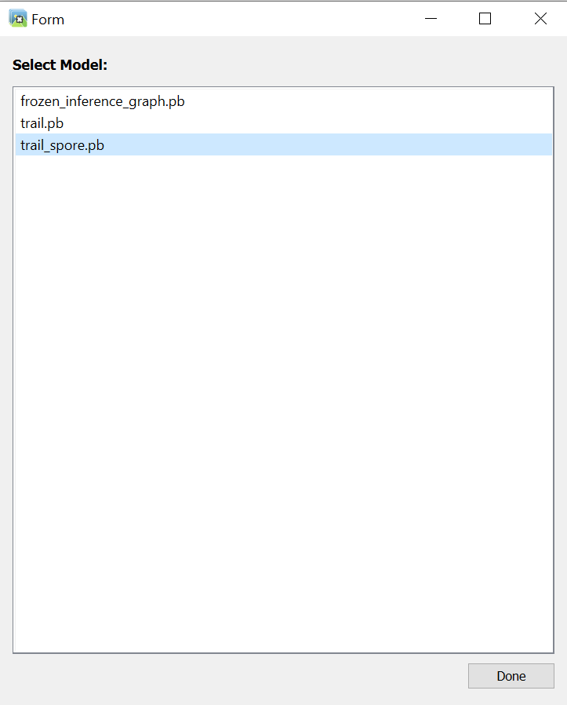

1. Again , normal flow from now onwards as user have list of all boxes detected by system on right panel.

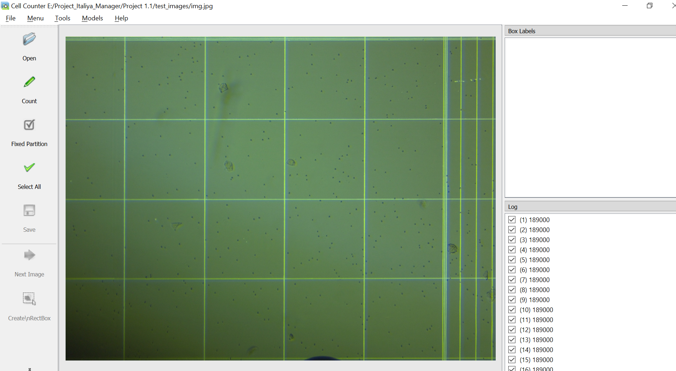

1. Press on Count button then, will display **count** on right side panel with green bordered indicated spores with accuracy determined by model as per references selected.

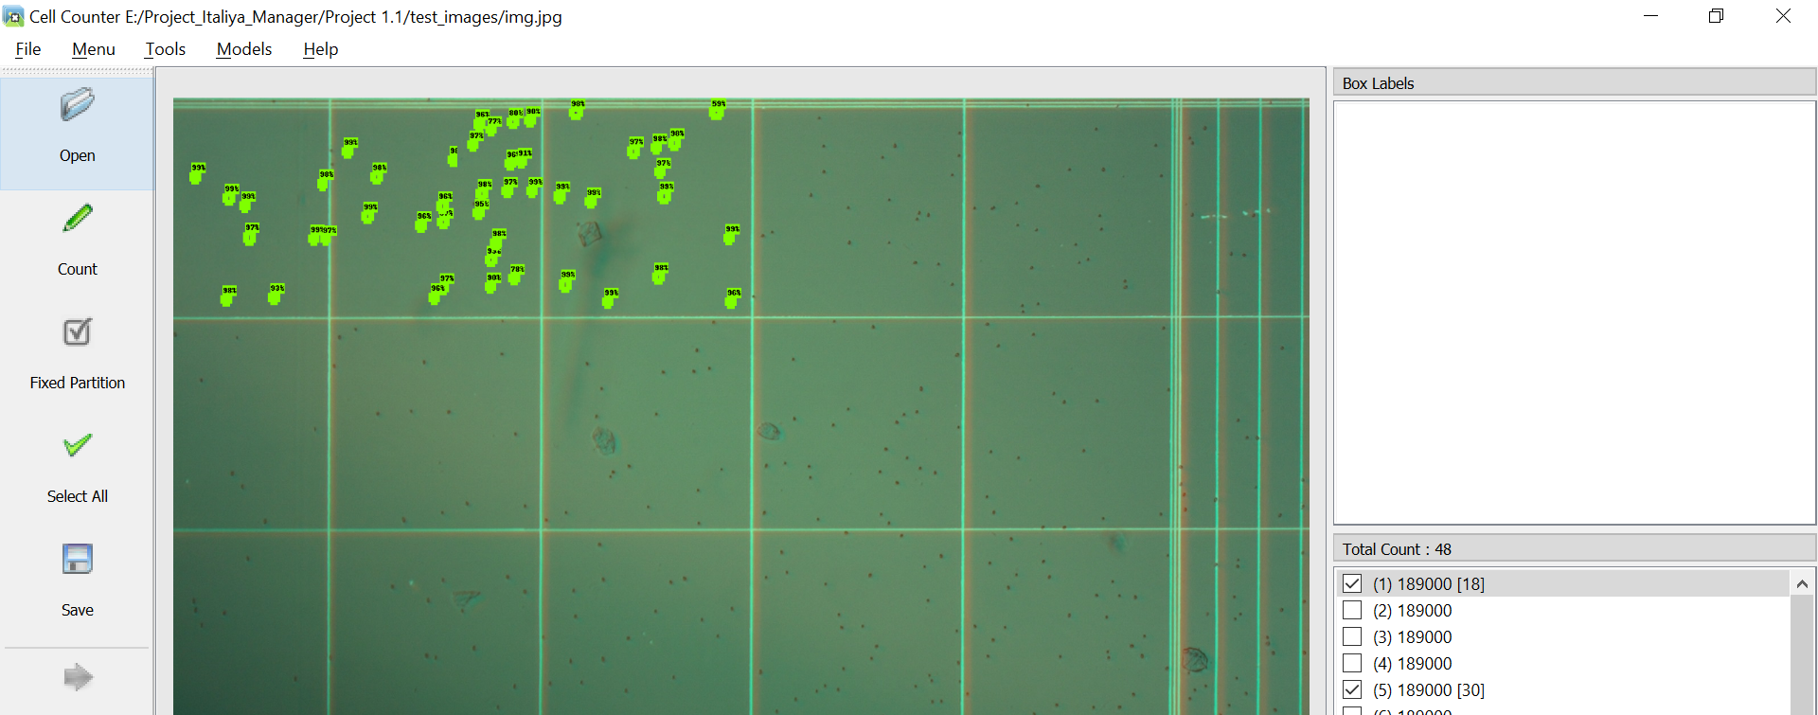

* User can add more labeling by going into **Tools ->Modify Label** and following window appears from where user can add label/ rename label/ delete label.

